**Implementprogramsforestimating&eliminatingtrendintime series data – aggregation, smoothing.**

**EX:No.5 DATE:1/02/25**

# AIM:

ToImplementprogramsforestimating&eliminatingtrendintimeseriesdata–aggregation,smoothing..

## OBJECTIVE:

Toestimateandremovetrendsintime-seriesairpollutiondatausingaggregationandsmoothingtechniques.

## BACKGROUND:

* Timeseriesdataoftenhastrendsthataffectanalysis.
* **Aggregation**(e.g.,monthly/yearlyaveraging)helpsidentifypatterns.
* **Smoothing**(e.g.,movingaverage,exponentialsmoothing)removesfluctuations.
* Trendeliminationimprovesforecastingandstationarity.

## SCOPEOFTHEPROGRAM:

* Loadandcleanairpollutiondata(2012-2021).
* Apply**aggregation**(monthly/yearlyaverages)toestimatetrends.
* Use**movingaveragesmoothing**toreducenoise.
* Apply**exponentialsmoothing**tohighlighttrends

**CODE:**

import pandas aspd

importnumpyas np

importmatplotlib.pyplotasplt

fromstatsmodels.tsa.apiimportSimpleExpSmoothing

defload_data(filename):

    df = pd.read_csv("/content/MSFT.csv")

    # Set the 'Date' column as the index and convert it to DatetimeIndex

    df['Date'] = pd.to_datetime(df['Date'])  # Convert 'Date' column to datetime objects

    df.set_index('Date', inplace=True)  # Set 'Date' column as index

    returndf

defaggregate_data(df, freq='W'):

    returndf.resample(freq).mean()

defmoving_average_smoothing(df, window=10):

    returndf.rolling(window=window).mean()

defexponential_smoothing(df, alpha=0.2):

    model = SimpleExpSmoothing(df).fit(smoothing_level=alpha, optimized=False)

    returnmodel.fittedvalues

defplot_results(original, smoothed, title):

    plt.figure(figsize=(12, 6))

    plt.plot(original, label='Original', alpha=0.6)

    plt.plot(smoothed, label='Smoothed', linewidth=2)

    plt.legend()

    plt.title(title)

    plt.show()

# Example usage

data_file = 'stock_prices.csv'  # Replace with your dataset

df = load_data(data_file)

closing_prices = df['Close']

# Aggregation

weekly_data = aggregate_data(df, 'W')

monthly_data = aggregate_data(df, 'M')

# Smoothing

ma_smoothed = moving_average_smoothing(closing_prices, window=10)

exp_smoothed = exponential_smoothing(closing_prices, alpha=0.2)

# Plot results

plot_results(closing_prices, ma_smoothed, 'Moving Average Smoothing')

plot_results(closing_prices, exp_smoothed, 'Exponential Smoothing')

# OUTPUT:

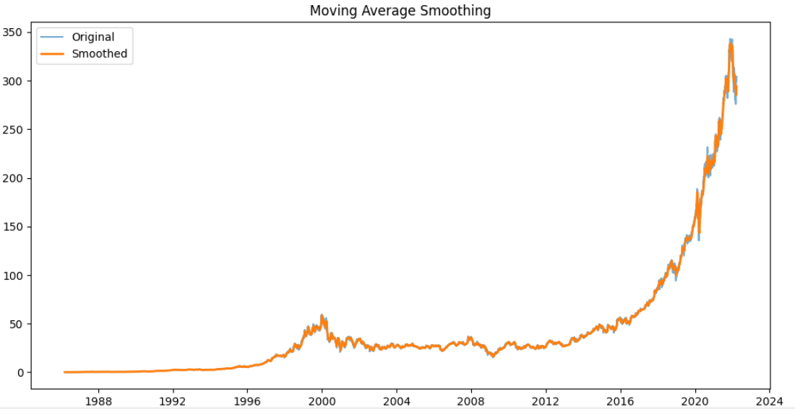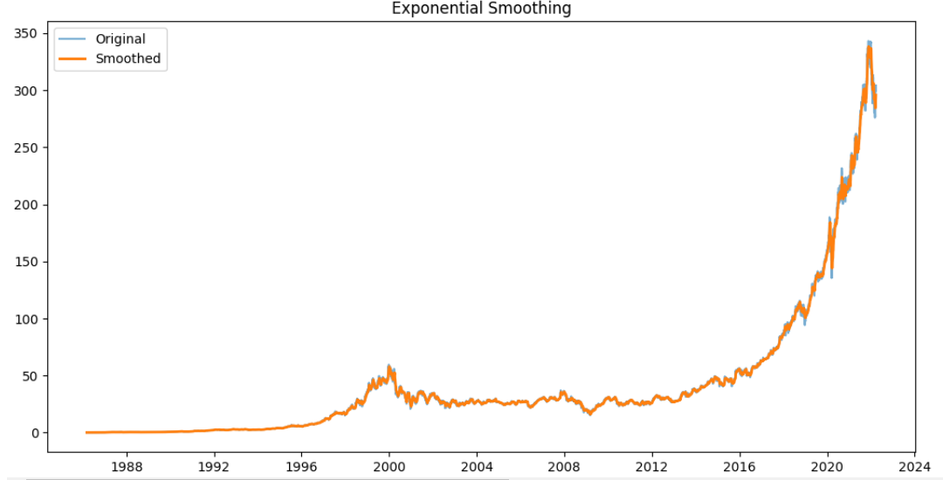

**RESULT:**

Thus,theprogramusingthetimeseriesdataimplementationhasbeendone successfully.